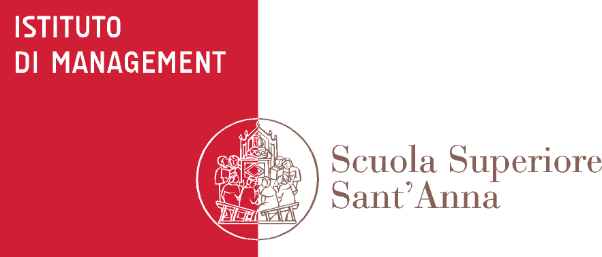
PhD in Management

Title of the course:Skills and tools for entrepreneurship and technology management

Lecturers: Andrea Piccaluga (picca@sssup.it) and Alberto Di Minin (alberto@sssup.it), Istituto di Management, Scuola Superiore Sant’Anna, Pisa

Short description of the course:
The course is designed to introduce all Scuola Superiore Sant’Anna PhD students (i.e. both social and experimental scientists) to the fundamental skills and tools regarding technology management in general and high-tech entrepreneurship in particolar. In particular, both management and S&T students are invited to partecipate, as well as students from Laws and Political Science. This will allow a multidscilinary approach. Management students will benefit from knowing the scientific literature and from interaction with their S&T colleagues who will bring real experiences. S&T students are expected to enhance their skills and learn new tools that will be useful for their research and/or managerial and/or entrepreneurial careers. The course will include some “traditional” one-way teaching but will be mostly based on students’ presentations and case study analysis.
Some external speakers (entrepreneurs, managers, consultants, etc.) will be also invited.

Student commitment
Upon enrolling into this course, students commit to come to class prepared to comment on the required readings. During the first lecture students will be divided into study groups, which will deliver in-class presentations. Attendance is compulsory.

Schedule, topics, descriptions, readings
The course is divided into two parts. During the first five classes we will explore relevant theories from business studies that are useful to improve our skills on innovation management and entrepreneurship. Discussion of these theories will be extremely applied; relevant experience of S&T students will be key to exemplify concepts that we will explore in class.
After the Christmas break, we will provide relevant practical tools that are going to be useful to apply on the field.

The course will take placeon Wednesdayfrom 10 am to 1 pm, in Room 3
at Polo Sant’Anna Valdera, (Viale Rinaldo Piaggio, 34) in Pontedera, with the following calendar.

Date | Topic | Required Readings | Hours
Nov 14, 2012 | Introduction to innovation management |  | 3
Nov 21, 2012 | Open Innovation  & open business models | Di Minin, A., F. Frattini, and A. Piccaluga. 2010. Fiat: Open Innovation in a Downturn (1993-2003). California Management Review, 52(3): 132-59.DOWLOAD  Chesbrough, H.W. 2007. Why companies should have open business models. Mit Sloan Management Review, 48(2): 22-28.DOWNLOAD | 3
Nov 28, 2012 | University-industry collaborations: why and how  Guest Speaker:  Riccardo Pietrabissa (Presidente Netval) | Etzkowitz, H. 1997. Innovation in innovation: the Triple Helix of university-industry.-government relations. Social Science Information, 42(3): 293-337.DOWNLOAD | 3
Dec 65 2012 | High-tech marketing  Guest Speaker: | Christensen, C.M., and M. Overdorf. 2000. Meeting the challenge of disruptive change. Harvard Business Review, 78(2): 66-78.  DOWNLOAD | 3
Dec 12, 2012 | Commodity trap and service based business models | Chesbrough, H. The Case for Open Services Innovation: the commodity trap. California Management Review, 53(3): 5-20.DOWNLOAD  Gawer, A., and M.A. Cusumano. 2008. How companies become platform leaders. Mit Sloan Management Review, 49(2): 28-35.DOWNLOAD | 3
Jan 16, 2013 | IP Management | Yoffie, D.B. 2005. Intellectual Property and Strategy. Harvard Business School, 2005(April 7).  DOWNLOAD  Oliver Alexy, P.C., Ammon Salter. 2009. Does IP strategy have to cripple Open Innovation? Mit Sloan Management Review(Fall): 71-77.  DOWNLOAD | 3
Jan 23, 2013 | Business planning |  | 3
Jan 30, 2013 | Entrepreneurship  Guest Speaker |  | 3
Feb 6,  2013 | Newcos: administration and taxes  Guest Speaker |  | 3
Feb 13, 2013 | Presenting your ideas to finance people  Guest speaker  Nicola Redi and others |  | 3

Final Examination
A final take-home exam will take place at the end of the course. Further details about the exam will be given at the beginning of the course.

Readings
Required readings will be distributed electronically by instructors.

References
You might be interested in reading the following references:
- Bianchi, Piccaluga (2012), La sfida del trasferimento tecnologico. Le università italiane si raccontano, Springer.
- Conti, Granieri, Piccaluga (2011), La gestione del trasferimento tecnologico, Springer.

